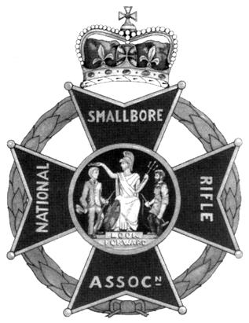 | National Small-bore Rifle Association  Youth Proficiency Scheme  Tutor’s Diploma Course  Sport Crossbow  Dates of course: 1st – 2nd November 2025 | 
Location: Priorslee & St. Georges Scout HQ Snedshill Way, Priorslee TF2 9QQ
(Grid Ref SJ70631008; Lat, Long: 52.687599, -2.435533; what3words: irony.ridge.pipes)

Start Time: 0845 for 09:00 Finish Time: 1700
Admin: Bring a packed lunch. Tea & Coffee will be available.
Outline: Qualify to deliver Sport Crossbow shooting as a Scout activity.
At the end of the course you should be able to:
- Take over an existing archery/sport crossbow range and run it safely with novice sport crossbow shooters,
- Set up a safe temporary sport crossbow range in a suitable location such as a Scout HQ or open space.
- Help a young person learn to shoot a sport crossbow competently,
- Run an approved introductory course for young people in target shooting with sport crossbows.

Topics Covered: Sport crossbow types & care, sport crossbow shooting stance & technique, plus revision of safety, crossbow law, building & running crossbow ranges, taster sessions, training games, the Youth Proficiency Scheme with regard to sport crossbows.

Cost:
Shropshire Scouting: £45  Other Scouting: £65  Non-Scouting: £105 | Cheques payable to “Shropshire Scouts” or make electronic payment to A/c No. 60814474, Sort code 20-77-85 with reference “Rifles[name]” and email countytreasurer@shropshirescouts.org.uk; john.dohoo@shropshirescouts.org.uk
Note: Holders of adult appointments in Scouting are welcome to stay overnight at the Priorslee HQ free of charge on Friday &/or Saturday nights indoors or camped on the grassed area behind, or in a campervan on the car park.

Questions / Queries / Special Needs: If you have any queries or special needs please contact John Dohoo, phone 01948 663249 or 07940 718924 or email john.dohoo@shropshirescouts.org.uk

To Register: Please complete the section below and return by post with payment cheque or (and preferably) email the information to john.dohoo@shropshirescouts.org.uk and make electronic payment as above.
-------------------------------------------------------------------------------------------------------------------------------------
YPST Sport Crossbow: 1st – 2nd November 2025 (Please print clearly & sign)
Name:
Address: |  | Postcode:
Telephone Nos.
Email:
Scout Group/District & County:
Scout Association Member No:

NSRA Member No:
Please list below any target shooting qualifications held:

I apply for a place on the above course and I:
Am interested / not interested in staying overnight at the HQ on Friday 31/10/25 &/or Saturday 1/11/25 and either
A: enclose a cheque for the course fee made payable to “Shropshire Scouts” or
B: confirm that I have made electronic payment to A/c No. 60814474, Sort code 20-77-85 with reference “RiflesYPSTXB[name]”. (delete whatever in italics does not apply)

Signed ………………………………………………………………………………………… Date ………………………

Please return to
J E Dohoo, Beech Croft, 31 Pear Tree Lane, WHITCHURCH Shropshire SY13 1NG (tel. & email as above)

