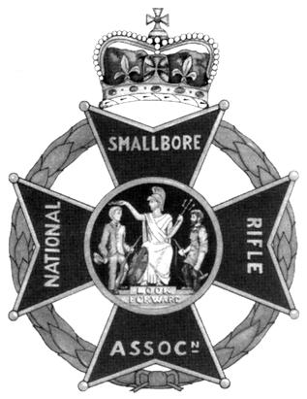 | National Small-bore Rifle Association  Youth Proficiency Scheme  Tutor Training Diploma Course  Air Rifle  Dates of course: 28th February – 1st March 2026  Venue: Priorslee & St. Georges Scout HQ | 
Snedshill Way, Priorslee TF2 9QQ (Grid Ref SJ70631008; Lat, Long: 52.687599, -2.435533; what3words: irony.ridge.pipes)

Start Time: 0845 for 09:00 both days Finish Time: 1700 both days

Admin: Non residential. Bring a packed lunch each day. Tea & Coffee will be available.
Outline: Qualify to deliver Air Rifle target shooting as a Scout activity.
At the end of the course, you should be able to:
- Take over an existing air rifle and run it safely,
- Set up a safe temporary airgun range in a suitable location such as a Scout HQ or open space.
- Help a young person learn to shoot an air rifle competently,
- Run an approved introductory course for young people in target shooting with sport air rifles.

Topics Covered: Organisation of the Sport, Safety, Law, Building & Running Ranges, Taster Sessions, Air Rifle types & care, Shooting position & Technique, Training Games, The Youth Proficiency Scheme

Cost:
Shropshire Scouting: £45  Other Scouting: £65  Non-Scouting: £105 | Cheques payable to “Shropshire Scouts” or make electronic payment to A/c No. 60814474, Sort code 20-77-85 with reference “Rifles[name]” and email countytreasurer@shropshirescouts.org.uk; john.dohoo@shropshirescouts.org.uk
Note: Holders of adult appointments in Scouting are welcome to stay overnight at the HQ free of charge on Friday &/or Saturday, indoors or camped on the grassed area behind, or in a campervan on the car park.

Questions / Queries / Special Needs: If you have any queries or special needs please contact John Dohoo, 01948 663249 / 07940 718924 or john.dohoo@shropshirescouts.org.uk

To Register: Please complete section below and return by post with payment cheque or email the information to john.dohoo@shropshirescouts.org.uk and make electronic payment as above.
-------------------------------------------------------------------------------------------------------------------------------------
YPST Air Rifle: Priorslee & St Georges 28th February – 1st March 2026 (Please type or print & sign)
Name:
Address:
Telephone Nos.
Email:
Scout Group/District & County:
Scout Association Member No: | Please detail below any target shooting qualifications held:
NSRA Member No:

I apply for a place on the above course and I:
A: enclose a cheque for the course fee made payable to “Shropshire Scouts” or
B: confirm that I have made electronic payment to A/c No. 60814474, Sort code 20-77-85 with reference “Rifles[name]”. (delete whichever does not apply)

Signed …………………………………………… (not required for email entry) Date ……………………

Please return to
J E Dohoo, Beech Croft, 31 Pear Tree Lane, WHITCHURCH Shropshire SY13 1NG (tel. & email as above)

