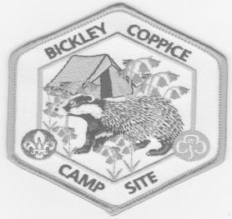Shrewsbury Scouts and Guides Campsite
Bickley Coppice, Bicton, Shrewsbury SY3 8EU

Booking Form 2025

*Contact Name |  |  | Leader in Charge:
*Unit or organisation |  |  | Shropshire Borders  Scout |  |  |  | Shrewsbury Division Guides
*Address

Telephone

*Date and time of arrival |  |  | *Date and time of Departure
*Total Number Camping |  |  | *Total number for day:
*Non returnable booking fee £ 10 |  |  |  | *Total due £
*Balance Outstanding to be paid within 14 days of end of event
Have you visited before Y/N How do you intend to arrive?
- Indicates box must be completed
Camping Areas: Please tick site required if known:
Eagle |  | Red Kite |  | Hawk |  | Stoat Spinney
Kestrel |  | Peregrine |  |  |  | Heron’s Reach
Other bookable areas – no charge
Main camp fire circle |  |  |  | Camping in rough areas

I have enclosed payment / I have transferred the payment of:
I have read the rules and booking conditions of the campsite and agree to abide with them
Signed Date:
(Leader in charge)

There is a NON-RETURNABLE BOOKING FEE of £10 for all bookings, which should be sent with the booking form.
Cheques to be made payable to: Bickley Coppice Campsite or by bank transfer to:
Bickley Coppice Campsite, Lloyds bank, sort code 309762, account 01350268
Confirmation of booking, gate and tap code will be emailed to the contact above.
Fees: £5.00 per person per night camping.
£30.00 day rate up to 40 participants.
£15.00 evening rate up to 40 participants.
For any other combinations, please email bookings@bickleycoppice.org.uk

Please send form and booking fee to:
BC Bookings, 12 Lythwood Road, Bayston Hill, Shrewsbury, SY3 0LU
Tel: 07855 902558

