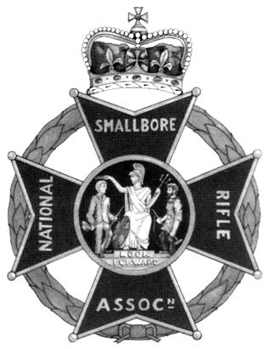 | National Small-bore Rifle Association  NSRA Club Coach Course  Dates of course: 20th & 21st June 2026  With assessments in July or August (dates tbd)  Course Venue: Priorslee & St.Georges Scout HQ  Snedshill Way, Priorslee TF2 9QQ | 
(Grid Ref SJ70631008; Lat, Long: 52.687599, -2.435533; what3words: irony.ridge.pipes)

Start Time: 0845 for 09:00 both days Finish Time: 1700 both days

Admin: Non residential. Bring a packed lunch each day. Tea & Coffee will be available.
Outline: The club coach course is not discipline specific and is an introduction into coaching. It deals mainly with coaching methods and communication, taking the technical skills in a shooting discipline already learned and using that learning to deliver effective training to others. It helps you take the step from instructing to coaching.

Essential Precursors: Current NSRA licences both (1) as a Club Instructor and (2) either NSRA RCO or NSRA YPS Tutor in an airgun discipline as appropriate to your Club Instructor licence. In addition you must either be an individual Life or Annual member of the NSRA or hold a current adult appointment in The Scout Association or the Cadet Forces.

Topics Covered: British shooting organisational structure, Law, Safety, Equipment, Communication, Presentation skills, Organisation, General goals of body positioning, Process of firing a shot, Helping people to learn, Putting it all together a practical coaching session, Code of conduct, General documents, Assessment.

Assessment: Candidates will deliver a 20 minute coaching session under observation. Assessments for this course will be held at Crewe Rifle and Pistol Club on a date to be agreed with the assessing County Coach or may be arranged with your own local County Coach.

Cost:
Shropshire & SW Cheshire Scouting: | £55 | Cheques payable to “Shropshire Scouts” or make electronic payment to A/c No. 60814474, Sort code 20-77-85 with reference “Rifles[name]” and email countytreasurer@shropshirescouts.org.uk; john.dohoo@shropshirescouts.org.uk
Other Scouting: £85
Non-Scouting: £135

To Register /Questions / Queries / Special Needs: Please complete the section below and return by post with payment cheque or email the information to john.dohoo@shropshirescouts.org.uk and make electronic payment as above.
If you have any queries or special needs please contact John Dohoo, email as above or 07940 718924.

-------------------------------------------------------------------------------------------------------------------------------------
Club Coach: Priorslee & St Georges 20th & 21st June 2026. (Please print clearly & sign or type & email)
Name:
Address:
Telephone Nos.
Email:
Scout Group/District & County or Cadet Forces appointment:
Scout Association or CFAV No: | NSRA Member No:
Please detail below your Club Instructor Licence(s) and any other relevant target shooting qualifications held (Description, Licence Number and Expiry date):

I apply for a place on the above course and I:
A: enclose a cheque for the course fee made payable to “Shropshire Scouts” or
B: confirm that I have made electronic payment to A/c No. 60814474, Sort code 20-77-85 with reference “Rifles[name]”. (delete whichever does not apply)

Signed ………………………………………………… (Signature not required if emailed) Date ………………………
Please return to J E Dohoo, by email or post to Beech Croft, 31 Pear Tree Lane, WHITCHURCH Shropshire SY13 1NG

